**Feasibility Study on ATM/ITM Demand for Production with KPI Metrics in Ethiopia**

Lijalem Gebrehiwet1*,

Researcher at Ethiopian Space Science and Geospatial Institute, Addis Ababa, Ethiopia (Msc)

lijalemgg2013@outlook.com

Yared Negussie2, Messayneh Woubshet3

Researchers at Manufacturing Technology and Engineering Industry R& D Center, Addis Ababa, Ethiopia (Msc)

yared222@yahoo.com  
messay65@gmail.com

*Corresponding author e-mail:lijalemgg2013@outlook.com*

**Abstract**

Automatic Teller Machines (ATM) is an innovative service delivery mode that offers diversified financial services. These are operated by the information and communication applications as a result in today’s business environment internet has major influences for all financial, banking and commercial transactions. ATMs allow bank customers to withdraw cash properly anytime, anywhere and at all hours without going to actual bank by online automation of banking transaction services. The customers also acquire different real-time service.As a result the cashless payment system adoption and innovation greatly helped the market growth forecasts of Automatic Teller Machine (ATM). This new technology is testing and demanding different finance institutions to be highly competitive in every aspect of economy. There are different types, designs and configuration of ATM/ITM machines. Their software and hardware must be confidential to support the banking services. CBE is the pioneer in introducing ATM payment system in Ethiopia and then after it got a Visa membership. Actually banking industry in Ethiopia hasn’t developed well and need to be modernized by introducing new E-banking technologies in the banking system therefore all banks operating in Ethiopia should recognize the need for introducing electronic banking system to satisfy their customers. These help them to fulfill the requirements of rapidly expanding domestic and international trades, and increasing international banking services. There is an increase in banks, bank branches and ATM usage by banks. The ATM demand is showing increment but there are no known companies that provide SKD/CKD assembling services. They are only imported as CKD and assembled for service by exporter representatives. For promotion of the E-banking in general and ATM in particular companies need to have their own assembling, service and maintenance factory due to the positive developments in financial, banking and commercial transactions

**Keywords**

ATM; ITM; E-banking; FI; Banking; Market

1. **Introduction**

An **Automated Teller Machine (ATM)** is defined as an electronic machine used for carrying out financial transactions to perform smooth banking transactions without the human cashier interaction in withdrawing cash from one’s account, making balance inquiries and transferring money from one account to another using a plastic, magnetic strip card by loading personal identification number issued by the financial institution [1] [2]. Automated Teller Machine (ATM) is known as automated banking machine (ABM) or Cash Machine (CM) [3]. In other word ATM, also called 24-hour tellers which give consumers the opportunity to bank at almost any time [4].

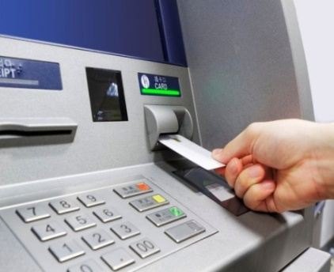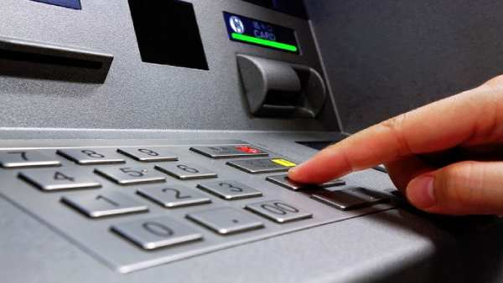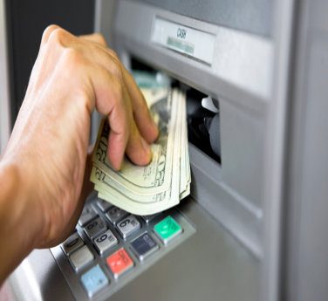

Sources oneindia.com

Figure 1. Cash withdrawal from ATMs

ATM works simple by inserting a card in the slot, punch in a few details and go home with hard cash [5]. ITM stands for Interactive Teller Machineand it look similar to an ATM except with virtual video and without cards. It assist with virtually transactions such as making payments to loans, withdrawing cash, depositing checks and cash with no deposit slips by simply touching the screen to speak to a personal teller [6][7][8]. ATMs allow doing a number of banking functions as shown below [9]. Regardless of all these benefits, like any other technology invention there are a few disadvantages of ATM regarding frauds and security breaches [10]. ITM functions just like a bank teller inside a normal bank and can perform a variety of services for the customer [11].

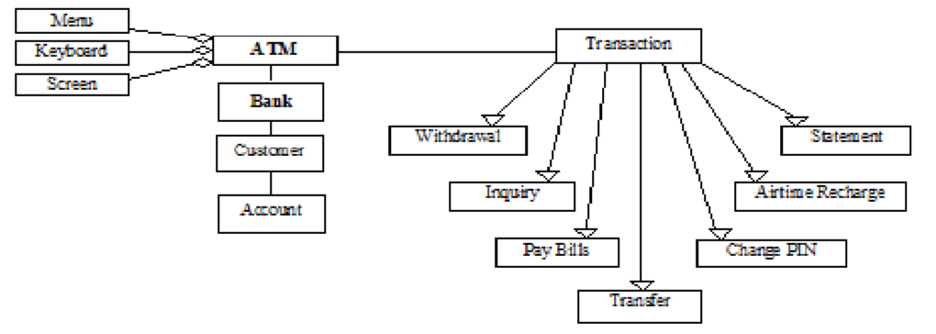

Figure 2. Functions of ATM

Interactive teller machines are essentially an evolved ATM and they’re providing an interesting option for financial institutions to serve customers in extremely rural or urban areas [14].

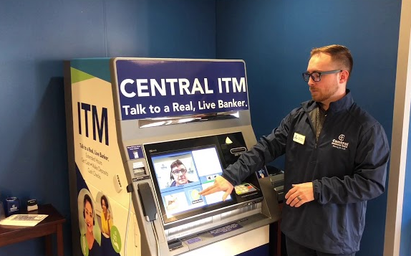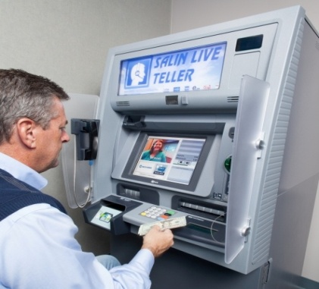

Source: Bussinesswire/Centralnational

Figure 3. ITM in use

* 1. **Common ATM/ITM types and original manufacturers**

For years, financial institutions have implemented ATMs for use by their customers. ITM offers more features to a customer than an ATM with live, video chat and uses a combination of touch screens with a video technology to offer in-person banking experience [15]. There are different top ATM manufacturers in the World such as Diebold Nixdorf, NCR Corporation, Triton LLC , Hitachi Channel Solutions Corp, GRG Banking Equipment Co. Ltd. , OKI Ltd., Nautilus Hyosung America, HESS Cash Systems, Fujitsu Ltd. , Euronet Worldwide Inc, and Brink’s, Inc [16]. There are different ATM Brands worldwide. Overall, ITMs are more expensive than ATMs. According to the [American Bankers Association](https://bankingjournal.aba.com/2020/03/despite-slow-pace-of-adoption-banks-are-interested-in-itms/), financial institutions have a ratio of one call ITM center for every 2.4 machines [17]. Of course, fully implementing an ITM likewise involves training and staff planning to make sure it gets introduced and used fully [18]. ATMs are also classified on the basis of labels assigned to them. Some of the labels are mentioned below [19];

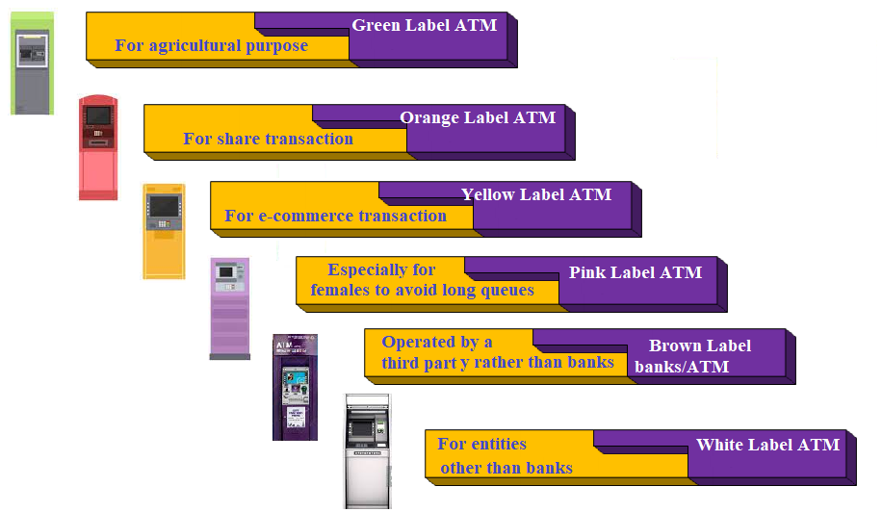

Figure 4. ATM labels

* 1. **Difference between ATM and ITM**

COVID-19 has a significant impact on customer behavior due to its behaviour of bad contacts which resulted in a rise in ITMs [20]. This real-time communication enables users to speak directly to customer service representative who can perform 80%–90% of the services. ITM software can “plug” directly into an FI’s banking platform, saving time, increasing customer data security, and ensuring accurate transaction results [21]. There are distinct differences between ATMs and ITMs technologies [22];

* 1. **Development of ATM**

In 1939 Luther Simjian came up with the idea of creating a "hole-in-the-wall machine" that would allow customers to make financial transactions and he invented automatic teller machine or ATM. The first ATM was introduced in Kingsdale Shopping Center Ohio, Canada in 1959. A British engineer Mr. James Goodfellow has come out with development of a security convention for a PIN and he developed a card which has PIN stored in the card itself in 1965 [23] [24].

**1971** *ATM developed that can take deposits, transfer money*

**Mid-70s** *Growth of shared networks accelerates*

*ared networks accelerates*

**Early 90s** National *EFT networks completed. Universal ATM access established*

**Mid-90s** Online *and offline debit transactions accelerate.*

*ATM system*

*Flourishes*

**1939** *Luther George Simjian invents the unsuccessful*

*Bankmatic automated teller machine*

***1968*** *Don Wetzel invented an American made ATM in*

**1969** *A working version of an ATM, manufactured by Docutel, is sold to New York’s Chemical Bank*

**Early 80s** *Emergence of widespread*

*ATM installation*

**1939** *Luther George Simjian invents the unsuccessful*

*Bankmatic automated teller machine*

***1968*** *Don Wetzel invented an American made ATM in*

**1969** *A working version of an ATM, manufactured by Docutel, is sold to New York’s Chemical Bank*

**Early 80s Emergence** *of widespread*

*ATM installation*

Figure 5. History of ATM [25]

In 1972, the first modern ATM came into operations. Don Wetzel, Tom Barnes, and George Chastain developed the first ATM cards to have a magnetic strip and a personal ID number to get cash. ATM cards had to be different from credit cards so account information could be included [26] [27]. ATM main chronologies are shown in Figure [28];

* 1. **Construction of ATM and ITM**

ATMs have a simple computer interface, allowing customers to handle their transaction both independent of a branch and without a teller [29].

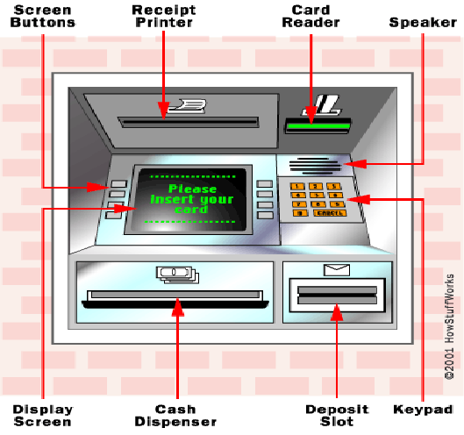

Figure 6. ATM parts

Different countries have different kinds of ATMs. But, the basic constructions from which they are developed are similar. There are different parts of ATM namely the input devices like card reader and keypad. The other output devices are cash dispenser, display screen, receipt printer and speaker as shown in the Table 1 [30] [31].

**Table 1. ATM parts [32]**

|  |  |  |
| --- | --- | --- |
| **Device type** | **ATM parts** | **Purpose** |
| Input  devices | Card reader | This reads the card’s magnetic stripe at rear or the card’s chip found at front |
| Keypad | It is used by the customer to feed information, the type of bank account, PIN, and amount of transaction |
| Output devices | Cash dispenser | This slot dispensed cash. This is situated at the bottom of the machine |
| Display screen | Guides the user to make the transaction. In case you need information about your bank account |
| Receipt printer | Every ATM can print receipts if the consumer requests for it. |
| Speaker | It provides the cardholder with auditory feedback when a key is pressed. |

There is hidden security camera which is also an integrated part of ATM to upgrade physical security. The purpose of this camera is to record 24 hours continuously and all activities done in ATM cabin by incoming person.

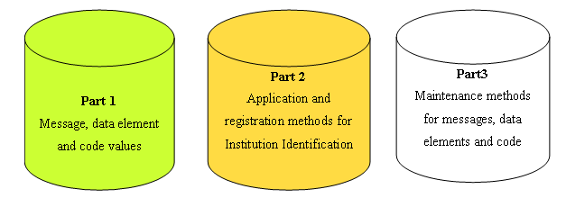

Figure 7. Parts in ISO 8583 platform supports

The housing of ATM is a hard cover which protects all inner parts and cash from theft. The ISO 8583 platform is an essential part of the transaction processing and this platform routes transaction between acquirers and issuers via its global transaction processing network. It has three parts [33]. The ATM hardware consists of CPU, magnetic or chip card reader, PIN pad, secures cryptoprocessor, display, function key or touch screen, record printer, vault and housing [34].

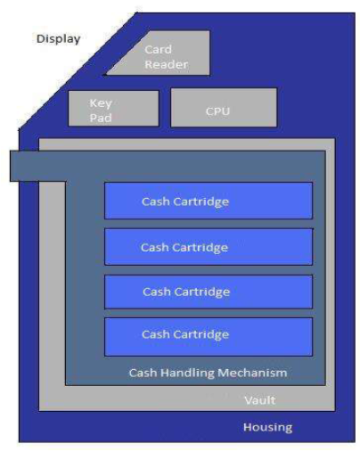 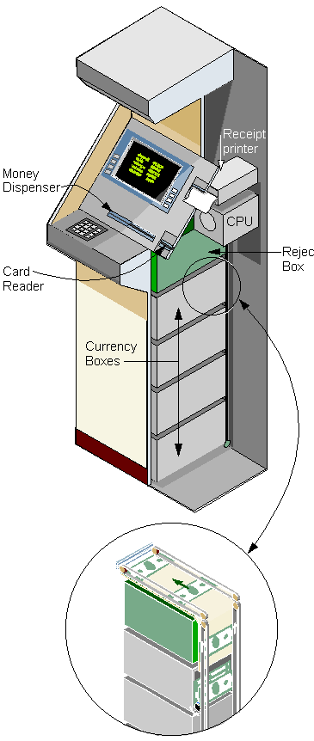

Source:gyanvihar.com/pcmag.com

Figure 8. ATM parts and block diagrams

* 1. **Operation of ATM and ITM**

A communications mechanism links the ATM directly to an ATM host network and the ATM functions much like a PC with an operating system and specific programs. Cards with magnetic bands are normally associated to a personal identification number (PIN). Once it is confirmed, the machine automatically connects to the bank’s main network [35] [36] [37].

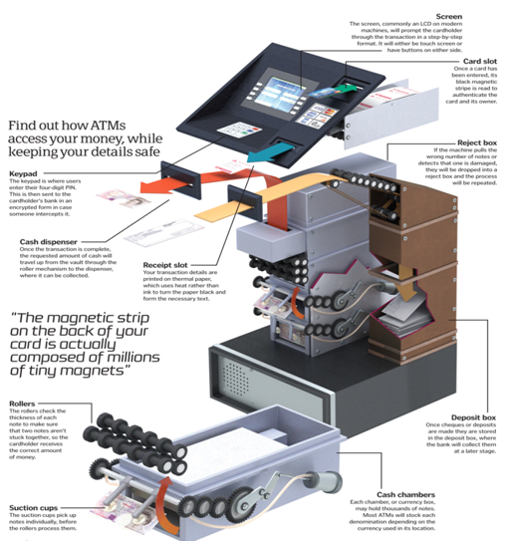

Figure 9. Operation of ATM [38]

ATM will then complete the money transaction that has been requested. ATMs are connected to interbank networks, enabling people to withdraw cash [30] [35] [36] [37] [38]. ITM is a video teller with a live person on the other side of the screen, which uses electronic signatures, ID verification and an opportunity to answer real questions [29]. ATM utilizes the vault or cash drawer within the merchant establishment, which allows for the use of a scrip cash dispenser [30].

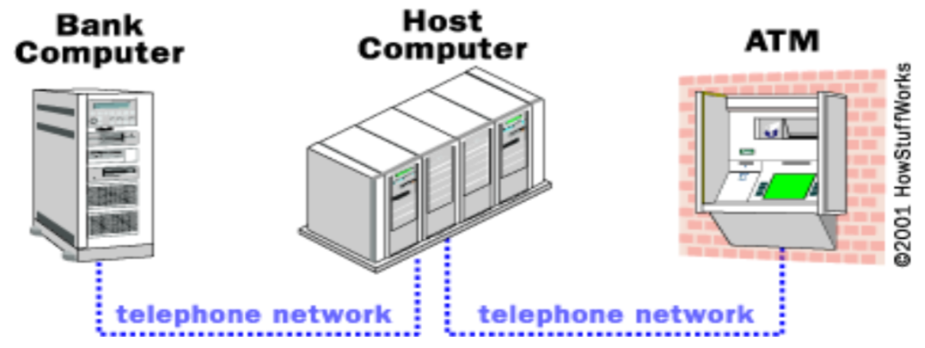

Figure 10. ATM interbank network

ATM networks are an integral part of new generation banking. All the ATM machines working around the world are based on the concept of centralized database system [39] [40]. The host processor is analogous to an internet service provider. All the various ATM networks become available to the cardholder and once the funds have been transferred, the ATM receives an approval code authorizing it to dispense the cash. Different networking may be used to connect to the host system such as leased line, dialup, or wireless data [30] [41] [42].

* 1. **ATM/ITM product requirements**

There are different requirements of ATM. The first type of requirements is the functional requirements which are categorized in to two types such as first requirement of the ATM and second requirement of the bank. The requirements for ATM consists of General Requirement; Requirement for Authorization; Requirement for transaction. The general requirements and authorization consists of different functional requirements [43] [44].

The requirement of the bank computer begins with authorization to get a request from the ATM to verify an account. In addition to this it consists of different types of functional requirements. The other type of requirement is external interface requirement such as user, hardware, software, and communication interfaces. The third type is performance requirements. Attributes is another type of requirement related to the availability of network for 24hrs, security, maintainability, transferability or conversion which is not applicable. The final type of requirement is the data base. The ATM must be able to use several data formats according to it that are provided by the data bases of different banks [43] [44].

Examples of the Hardware Requirements are;

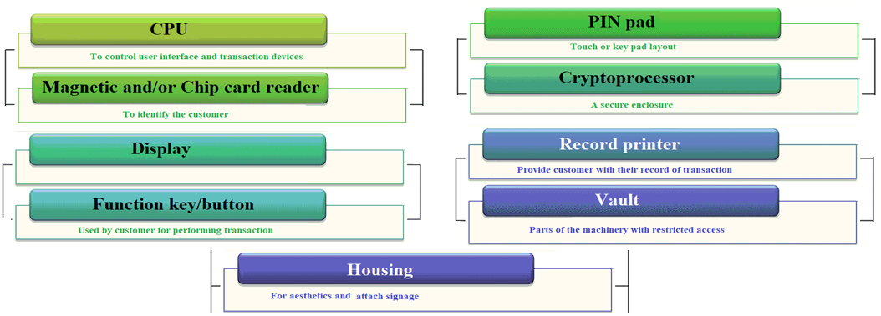

Figure 11. Hardware requirements

Software requirements include standard commercial off-the-shelf operating systems and this programming environment can be used by ATMs. Currently, vast majority of ATMs worldwide use a Microsoft OS such as Windows XP Professional or Windows XP Embedded. Some products still running with older versions such as Windows NT, Windows CE or Windows 2000 [5].

* 1. **ATM/ITM technical parameters**

Standards for ATMs already exist in some developed countries. A standard for ATMs was developed in Australia and it gives ATM dimensions based on anthropometric measurements of the Australian population. Due to the differences in population anthropometric measurements between countries, dimensions of the Australian or any other standard may not be ergonomically suitable for people in other countries, where there are no ATM standards like in Africa and Saudi Arabia [45][46]. Technically four of the most important dimensions that might have direct impact on the interaction between the user and the ATM. The screen height should be comfortably visible to the user and, therefore, close to their eye height. The height of the ATM screen is the distance between the floor and the middle of the screen according to different research studies. This height is compared to an optimum screen height estimated to be 300 mm below eye height of the 50th percentile of the user population [45] [47].

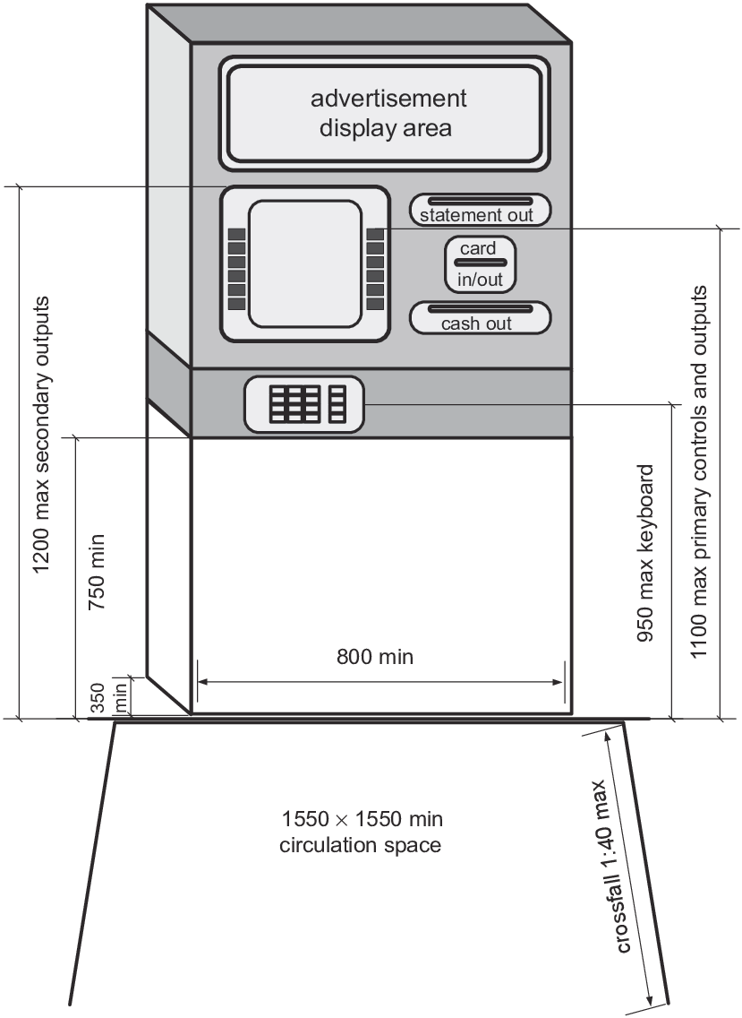

Figure 12. ATM machine recommended in Australian standards [46]

The other dimension is the Keyboard height. Using keyboards may be considered as precision work. It is recommended such precision work to be done 0–100 mm above elbow height [48]. The third dimension which is the card slot height and must be visible to the user and easy to insert the card. It is estimated that an optimum card slot height would be 100 mm above the average elbow height. In cash slot height, the slots must be visible to the user and easy to reach. According to different ATM research studies, the optimum cash slot height would be 50 mm above the average elbow height of adult user population [45] [47].

The recommended work levels for ATMs are 50–100 mm above elbow height for delicate manipulative tasks. For better manipulative tasks, the level 50–100 mm below elbow height involving a moderate degree of both force and precision where as 100–250 mm below elbow height is better for heavy manipulative tasks [47][49] [50].

In Pakistan the average temperature of working space of ATMs is 24o C and they recommended the temperature of workspace should be equal to 30o C. The recommended dimension given by researchers is shown below [51];

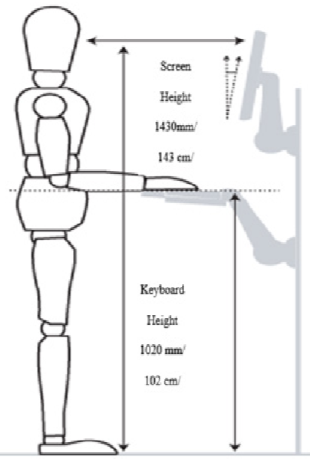

Figure 13. Average working space standard

* 1. **ATM/ITM manufacturing process, production lines, shops and maintenance centers**

The production line is a complex of machines stacked together and controlled so that they function as an integrated whole. The number of production line positions depends on the need and technical specification of a product. The end result of a production line can be result of: processing, handling, transport, packaging, etc. [52]. There are a few basic types of manufacturing activities such as one unit production, small batch production, mass production, and continuous production [53].

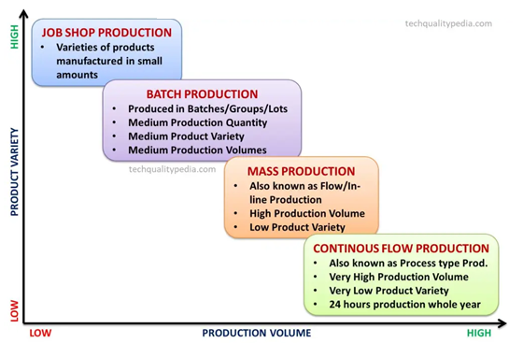

Figure 14. Manufacturing/Production process types

If you’re on an especially tight timeline to install a new machine, and you only require a few customary features, such as cash withdrawal and cash deposits, as mentioned above, it may make more sense to order an ATM. Industry average installation time for ATMs can be around two to four weeks [54].

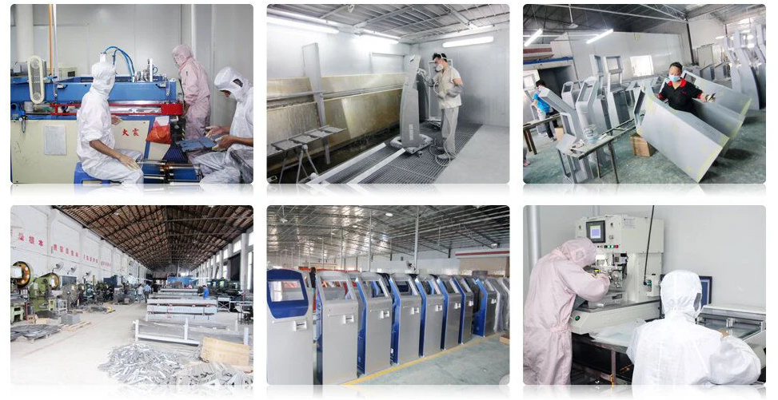

Figure 15. ATM workshop [54]

The ITM could be of greater value to an organization, if there are time and resources to adopt a new service. An ATM is convenient, easy to use and familiar to many customers with comfortable [55] [56][57][58].

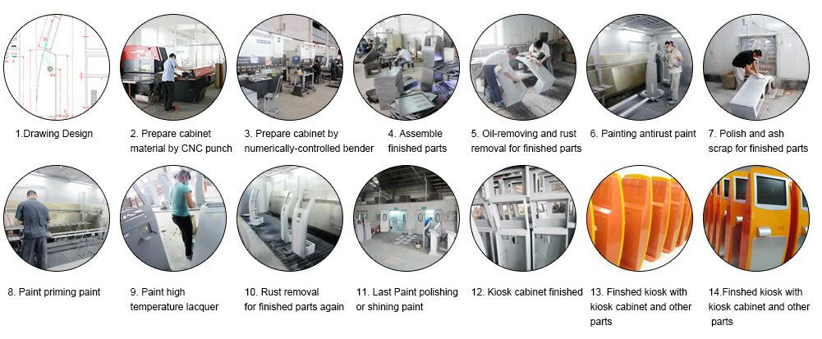

Figure 16. ATM Production Process [54]

The suppliers provide raw materials to producers, products manufactured by manufacturers are distributed to operators through warehouses, and maintenance centers provide necessary maintenance components to maintain and upgrade ATMs [59].

During ATM production, employees use a winch to lower the head module unit of an automated teller machine (ATM) on the production line and position the head module unit. Other tasks are assembling of the card reader unit, assembly works on the key pad unit, securing the head module unit and finally screen tests are carried out. Repair in the bank ATM are mostly done by an ATM technician and is responsible for the maintenance, hardware, firmware or software upgrades and on-site diagnosis. Example of use case diagram for working of ATM technician is shown below [60];

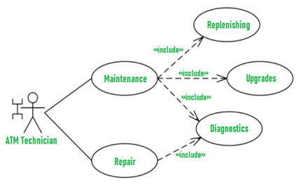

Figure 17. ATM technicians’ use case diagram

In ATM maintenance, types of ATM OEM’s, brands of ATM, supervisor mode quick run, the likely problems and solutions, call logging and call closure, parts identification and installation, technology mode repairs, hardware parts and replacement, field support specialist, cassette configuration and troubleshooting should be clearly understood.

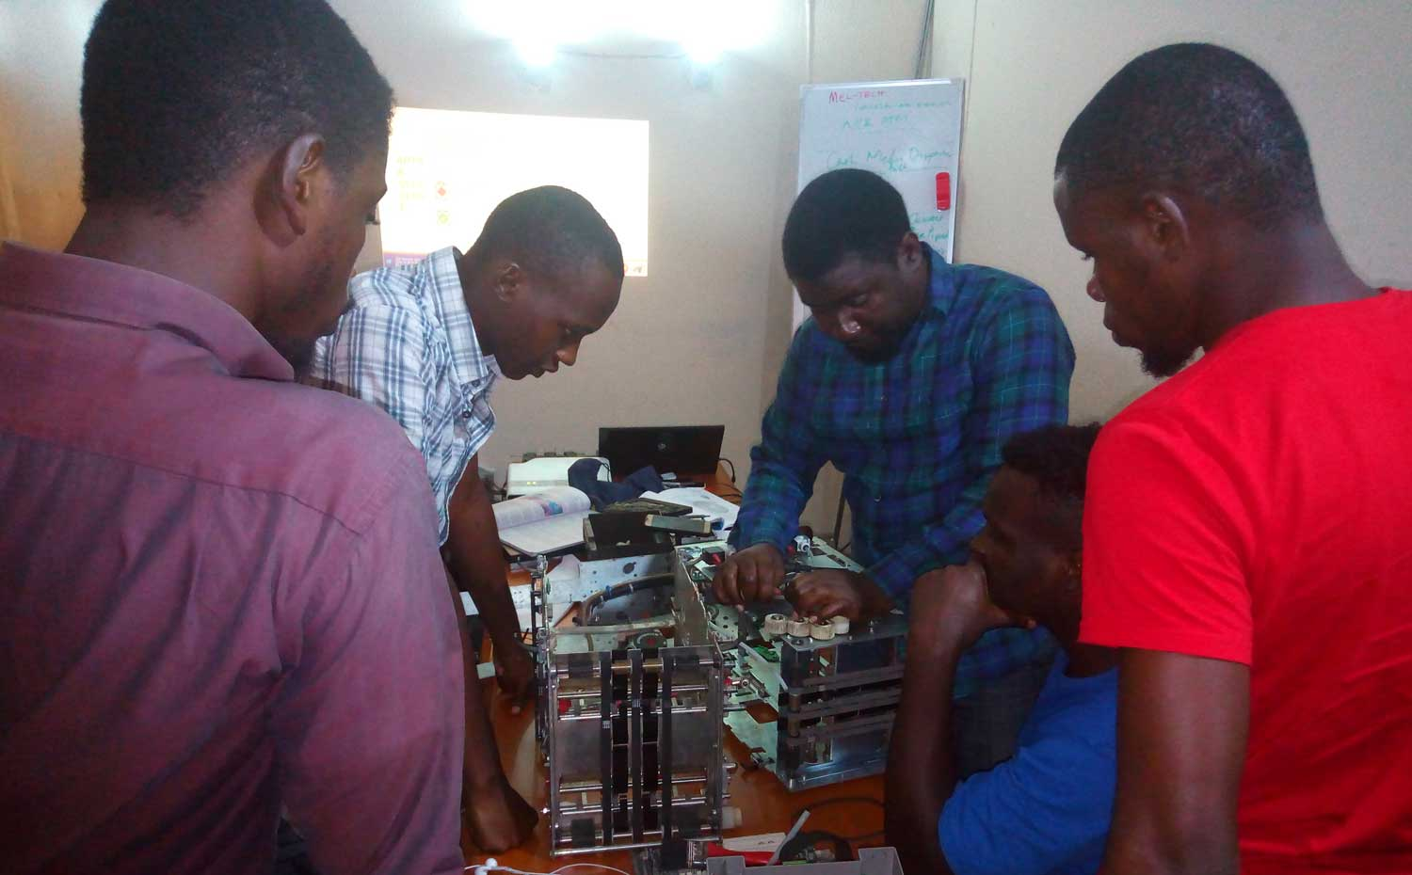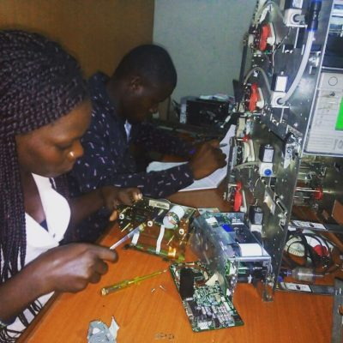

Figure 18. Maintenance at MEL-Technologies [61]

1. **Production volume and KPI definitions**
   1. **Production Volume, standard hours, KPI and stock system**

Production volume measures the total amount a company can produce over time. KPI tracks the total number of products manufactured over a set period of time and focuses on total output. They are metered in days, weeks, months, quarters, and years [62]. Applying production volume correctly can help manage the inventory levels more effectively and make better decisions about where to spend budget dollars [63].

To measure production volume, it requires to first selecting the time period we plan to monitor. The overall production data should be collected on every product manufactured and combine it to form an aggregate figure. The useful indicators are weekly production numbers, production quantities per product and changes in volume over time. Three types of resources are used for their production: labor, material and financial resources [62] [64].

KPI is assorted variables that organizations use to assess, analyze and track manufacturing processes. These performance measurements are commonly used to evaluate success in relation to goals and objectives [65]. The Balanced Scorecard Institute’s (BSI) **Measure-Perform-Review-Adapt (MPRA)** framework is a disciplined, practical, and tested approach for developing and implementing a KPI system.

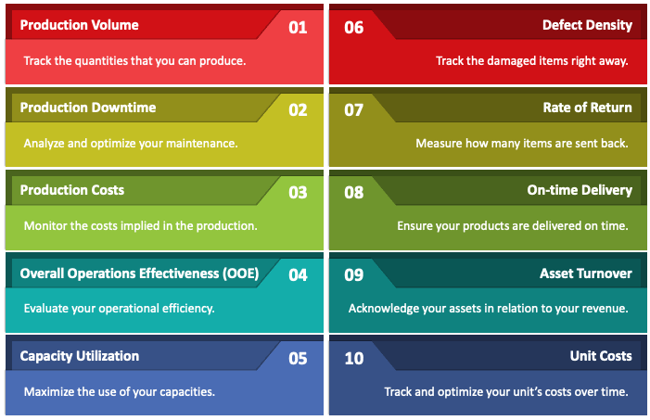

Source: sketchbubble

Figure 19. Manufacturing KPIs and Metrics

Developing a measurement in KPI is the starting point for the improvement process. Once measures have been established, the Perform-Review-Adapt cycle gives the organization a chance to take improvement actions, assess impact, and finally adapt the system [65] [66]. The ISO 22400 has defined a set of KPIs to evaluate the performance of manufacturing operation. KPIs seem to be inspired from the discrete production context but do not automatically fit the process industry context easily [67]. The top 15 smart factory KPI measured factors are shown below [68];

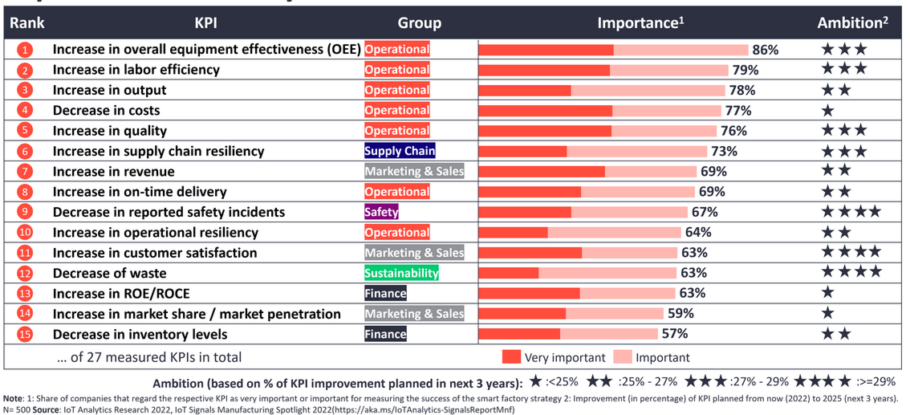

Figure 20. Top 15 smart factory KPIs

Visual management is the process of displaying critical information such as production output, efficiency and quality. The seven common productions KPI are; count (good or bad), reject ratio, rate, target, takt time, overall equipment effectiveness (OEE) and downtime [65].

* 1. **ATM Market growth**

Installation of ATMs has been particularly rapid in recent years. ATM growth was 9.3 percent per year from 1983 to 1995 but accelerated to an annual pace of 15.5 percent from 1996 to 2002. Much of the acceleration is due to placing ATMs in locations other than bank offices. These off-premise ATMs accounted for only 26 percent of total U.S. ATMs in 1994, but now account for 60 percent [69]. The digitization of all government transactions will act as a foundational building block for increasing the use of digital payments in the country. There are four types of digital transactions in the Ethiopian market today: ATM, POS, Mobile banking and Internet banking transactions [70].

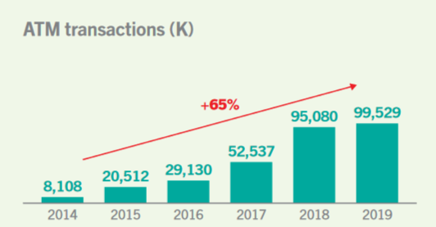

Figure 21. ATM digital transaction in Ethiopia

Numbers of automated teller machines (ATMs) in South Africa in 2022 and 2023, by bank are shown below to compare the values with other African countries.

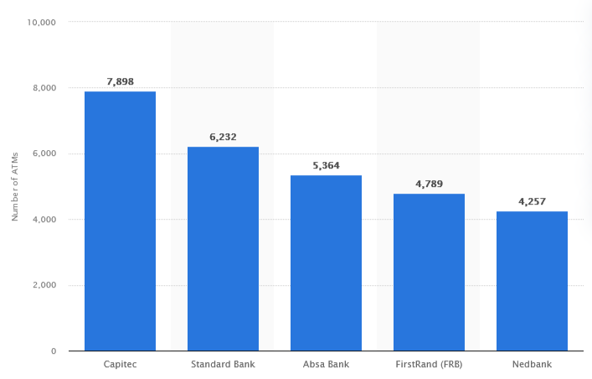

Figure 22. Number of ATMs in South Africa in different banks [71]

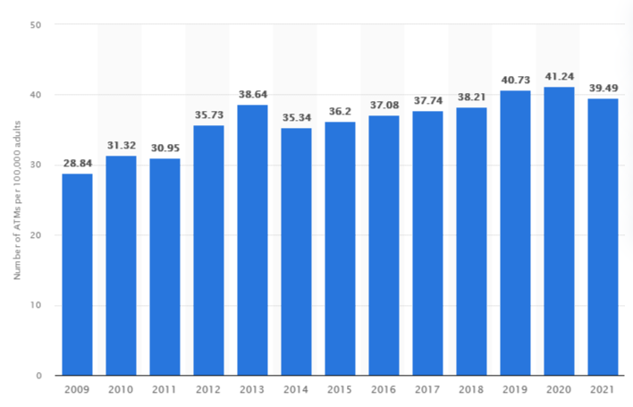

Figure 23. Number of ATMs globally from 2009 to 2021 (per 100,000 adults)

In 2021, the number of ATMs in the world decreased by 1.8 machines per 100,000 population of adults since 2020. Nevertheless, the last two years recorded a significant higher number of ATM than the preceding years [72]. As per the ATM Statistics computed by Reserve Bank of India, total number of onsite and offsite ATMs of all Indian Banks are 100042 by July 2012 [73].

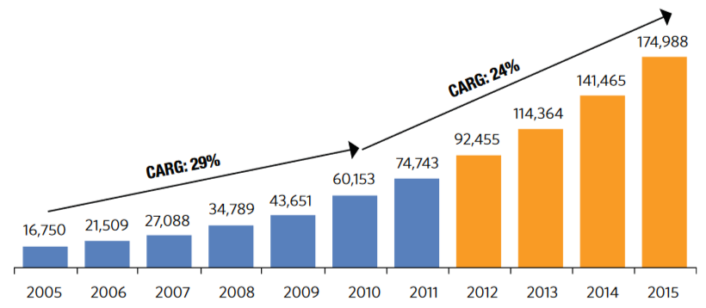

(Source: Edelweiss IB Estimates; Assumed a 24% growth rate for the period 2012 - 2015)

Figure 24. Yearly estimates of ATM numbers in India

In India, service providers take the different responsibilities such as identification of ATM installation site, connectivity, power arrangement, negotiation with landlords, and finishing the interiors site. Banks in India don’t have the core competencies to handle these issues [74]. Some ATM manufacturers tend to charge for a software suite, depending on the abilities of the machine. According to [Tellerex](https://www.tellerex.com/post/new-atm-cost?&_ga=2.259064462.500648483.1691058668-173565976.1691058653#:~:text=Whether%20improving%20security%2C%20increasing%20functionality,cost%20anywhere%20from%20%24300%E2%80%931%2C000) a normal ATM software package can cost around $2,000 for simple cash dispensing tasks. ATM machines with more complex software functions can cost up to $3,000 with additional costs such as software upgrades and subscriptions [75] [76].

* 1. **Cost of operation or process costing**

Cost of operation are defined as expenditures directly related to day-to-day business activities, excluding the processes involved in manufacturing a product or delivering a service. Operating and non-operating expenses can be fixed. They are unaffected by changes in production volume and service delivery which fluctuate in proportion to the changes in volume or delivery [77] [78]. Process costing is an accounting method typically used by companies that produce in mass of very similar or identical products or units and it doesn’t make sense to try to track individual unit costs throughout production process [79].

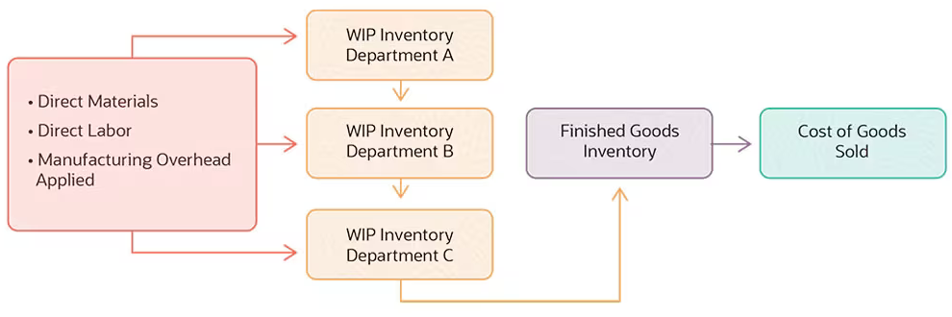

Figure 25. Cost flows in process costing

The process costing helps companies to track the flow of costs from department to department, rather than identifying costs for each individual item. Companies may use separate work-in-process inventory accounts for each department [79] [80] [81]. A manufacturing company incurs both manufacturing costs which are called as product costs and non-manufacturing costs. They are also called as selling and administrative expenses [82]. Total manufacturing cost can be calculated with a simple formula shown below [78] [83]:

**Total manufacturing cost = Direct materials + Direct labour + Manufacturing overheads - - - (eq 1)**

The total cost of each activity consumed by a product is calculated as the sum of the product. It is the cost driver rate of the activity and the practical capacity of the activity consumed by the product. The cost of the activity consumed by the product is calculated by multiplying the practical capacity of the activity consumed by the product. It is usually calculated with the corresponding cost driver rate of the activity [84].

- - - - - - - - - - - - - - - - - - - - - - - - - - - - - - - - - - - - - - - - - - - - - - - - - (eq 2)

Where Cp= Total cost of activity consumed by the product

ACp= Activity consumed by the product

m= number of activities

If banks or credit unions want to calculate the ROI of ATM machines, they need to start by determining the overall cost. Remember. The initial ATM price tag tells only smaller part of the overall cost value. There are numerous factors contributing to the cost of a new ATM namely hardware and software installation and their maintenance costs [85].

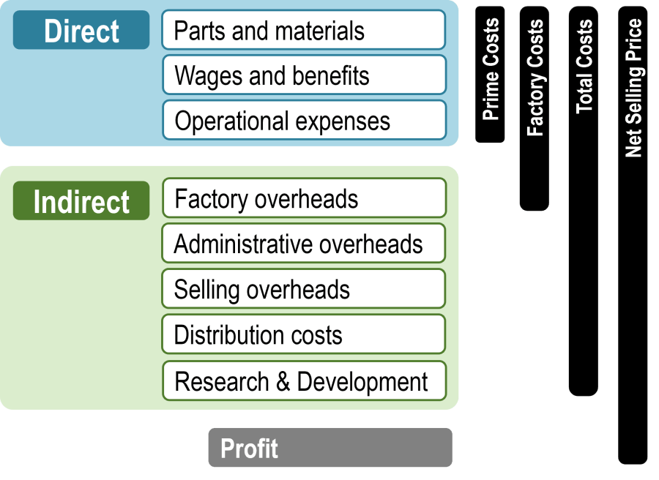

Figure 26. Manufacturing cost structure [86]

Automated teller machines have remained a popular banking feature for the better part of a century. ATMs have grown in complexity, challenges and here by increased in cost [86] [87]. Many financial institutions are finding it increasingly difficult to keep up with the pace of change in technology, regulations and consumer expectations as the result of ATM and self-service channel becomes more complex and integrated. Some research survey sought to explore respondents’ cost pressures, key operational challenges in terms of vendor, device, cash management, and the metrics. These KPIs use to assess the performance of their ATM fleets [88]. **On average,** an ATM machine can cost between $2,000 and $4,000 for standalone ones. $5,000 and $10,000 for wall types **[89].**

The average cost of ATM hardware for a financial institution is around $30,000, but that number can change considerably. The cost of ATM software depends on the manufacturer and the functions they support. The costs are **$1,500–2,500** per ATM for simple cash-dispensing duties and **$2,000–4,000** per ATM for deposit automation or other complex functions. Additionally, there may be added software costs for the systems that support ATMs. The whole supply chain is part of the ATM lifecycle [90] [91].

A few things that might affect the cost include: maintenance coverage hours, service level agreements, such as response time and uptime. Maintenance issues that don’t require tools or opening the ATM are called first line maintenance (FLM). FLM is often taken care of by experienced branch staff and no technicians required which saves a lot of money. On the other hand, it can be impractical to ask branch staff to [troubleshoot ATMs](https://www.tellerex.com/post/atm-troubleshooting-levels), and the extra maintenance costs may be warranted. In addition, remote ATMs will always require technicians for FLM and SLM. Furthermore, ATMs typically require some level of software maintenance [91] [92].

1. **Methodology**

There are no known ATM assembling companies in Ethiopia. The rise in establishment of banks and branches has good opportunity to ATM assembly firm with optimistic market shares. Currently an ATM/ITM machines are assembled by foreign firms and doesn’t have any assembling facility for SKD/CKD kits but they just imported in CBU form. The main methodology followed is to identify the ATM market demand is by enumerating the current bank branches and number of ATMs in service. The weighted decision matrix values for different bank criteria can help us predict their two years demand projection. This helps to compare and contrast worldwide ATM usages of Ethiopia which has key factors to consider in E-banking in order to promote the technology. The actual data are collected in 2023 and the demand projection is performed only for two years due to the nature of the E-commerce and community.

1. **RESULT AND DISCUSSIONS**

There are 9458 bank branches in Ethiopia on 2023 and their ATM/ITM capacities in service are 6325. The estimated demand projection capacity will be 12370 ATMs on 2025. The detailed data are tabulated below supported by different charts which greatly help assemblers or importers to assemble either the SKD or CKD kits which also help them promote the E-banking benefits both for the banks and community.

* 1. **Total number of Banks and Branches in Ethiopia**

Banking service in Ethiopia started in 1905, with the establishment of the bank of Abyssinia that was owned by the Ethiopian government in partnership with national bank of Egypt then under British rule. However a well structure banking system is started to in 1940s after the Italian departure. The state bank of Ethiopia was established in 1942. A number of foreign bank branches and private bank were operating in competition with the government owned commercial bank until they were in 1976 [93] [94]. A proclamation number 84/94 was issued out to effect the deregulation and liberalization of the financial sector. Many private banks and insurance companies were established following the proclamation and there were 16 private banks operating along with three public banks in 2013/14 [95] [96].

The Commercial Bank of Ethiopia (CBE), the largest bank in the industry, accounts 38.8% of the branch networks but it remained as one of the under-banked countries even at sub-Saharan African countries standard [64]. The distribution of bank branches was highly situated to major towns & cities with nearly 34 percent of bank branches were located in Addis Ababa [94] [95].

There were only nineteen commercial banks for the 96.9 million population of the country according to the data from 2013/14 fiscal year. The research data shows the per capita commercial bank is very low about 5.7 million populations per one commercial bank which indicates the limited access of the population to financial services [94].

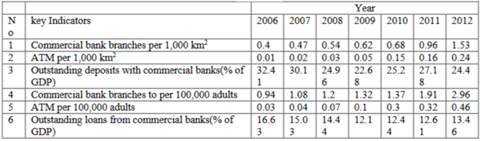

Figure 27. Financial services access and use in Ethiopia [96]

By the standards of these countries, and indeed by the standard of many African countries, Ethiopia is a highly under-banked country. Almost in all cases, formal bank operate in towns with a population above 20 thousand which indicates they are inaccessible to the rural population and to many small towns. Evidence suggests that only less than 1% of rural population have bank accounts. The fact that the Addis Ababa city alone claims for one-third of the total bank branches itself is a good indicator that access to formal banking services is limited [97]. Generally banks in Ethiopia are under development. The total number of banks and branches are tabulated below to estimate the demand for ATM and ITM.

**Table 2. Total number of branches in each bank [Reference from bank’s current data]**

|  |  |  |  |
| --- | --- | --- | --- |
| **S/N** | **Bank Name** | **Year Est.** | **No of Branches** |
| 1 | [Nib International Bank](https://en.wikipedia.org/w/index.php?title=Nib_International_Bank&action=edit&redlink=1) | 1999 | 211 |
| 2 | [Abay Bank](https://en.wikipedia.org/w/index.php?title=Abay_Bank&action=edit&redlink=1) | 2010 | 467 |
| 3 | [Addis International Bank](https://en.wikipedia.org/w/index.php?title=Addis_International_Bank&action=edit&redlink=1) | 2011 | 133 |
| 4 | [Awash International Bank](https://en.wikipedia.org/wiki/Awash_International_Bank) | 1994 | 446 |
| 5 | [Bank of Abyssinia](https://en.wikipedia.org/w/index.php?title=Bank_of_Abyssinia&action=edit&redlink=1) | 1996 | 818 |
| 6 | [Berhan International Bank](https://en.wikipedia.org/w/index.php?title=Berhan_International_Bank&action=edit&redlink=1) | 2010 | 327 |
| 7 | [Bunna International Bank](https://en.wikipedia.org/w/index.php?title=Bunna_International_Bank&action=edit&redlink=1) | 2009 | 463 |
| 8 | [Commercial Bank of Ethiopia](https://en.wikipedia.org/wiki/Commercial_Bank_of_Ethiopia) (State Bank) | 1963 | 1824 |
| 9 | [Cooperative Bank of Oromia](https://en.wikipedia.org/wiki/Cooperative_Bank_of_Oromia) | 2005 | 738 |
| 10 | [Dashen Bank](https://en.wikipedia.org/w/index.php?title=Dashen_Bank&action=edit&redlink=1) | 1995 | 800 |
| 11 | [Debub Global Bank](https://en.wikipedia.org/w/index.php?title=Debub_Global_Bank&action=edit&redlink=1) | 2012 | 158 |
| 12 | [Enat Bank](https://en.wikipedia.org/wiki/Enat_Bank) | 2013 | 167 |
| 13 | [Lion International Bank](https://anbesabank.com/) | 2006 | [278](https://anbesabank.com/branch-locator/) |
| 14 | [Oromia International Bank](https://en.wikipedia.org/wiki/Oromia_International_Bank) | 2008 | 500 |
| 15 | [Hibret Bank](https://en.wikipedia.org/w/index.php?title=Hibret_Bank_(Ethiopia)&action=edit&redlink=1) | 1998 | 470 |
| 16 | [Wegagen Bank](https://en.wikipedia.org/wiki/Wegagen_Bank) | 1997 | 400 |
| 17 | [Zemen Bank](https://en.wikipedia.org/w/index.php?title=Zemen_Bank&action=edit&redlink=1) | 2009 | 96 |
| 18 | [Development Bank of Ethiopia](https://en.wikipedia.org/wiki/Development_Bank_of_Ethiopia) | 1901 | 32 |
| 19 | [ZamZam Bank](https://en.wikipedia.org/w/index.php?title=ZamZam_Bank&action=edit&redlink=1) | 2021 | 75 |
| 20 | [Hijra Bank](https://en.wikipedia.org/w/index.php?title=Hijra_Bank&action=edit&redlink=1) | 2021 | 72 |
| 21 | [Siinqee Bank](https://en.wikipedia.org/w/index.php?title=Siinqee_Bank&action=edit&redlink=1) | 2021 | 406 |
| 22 | [Shabelle Bank](https://en.wikipedia.org/w/index.php?title=Shabelle_Bank&action=edit&redlink=1) | 2021 | 52 |
| 23 | [Amhara Bank](https://en.wikipedia.org/w/index.php?title=Amhara_Bank&action=edit&redlink=1) | 2021 | 281 |
| 24 | Ahadu Bank | 2022 | 10 |
| 26 | Tsedey Bank | 2022 | 148 |
| 27 | Sidama Bank | 2022 | 16 |
| 28 | Gadaa Bank SC | 2023 | 70 |
| **Total number of branches** | | | 9458 |
|  |  |  |  |

* 1. **Estimated current demands of ATM**

Financial service industries are going through an exciting period of innovation and evolution. According to the research data of center for financial inclusion, 24 percent of people in low-income countries have a bank account when compared to 89 percent of citizens of high-income nations [98] [99]. The overall cash use is going up in various markets as a result of economic growth and higher total spending as shown by the PYMNTS global cash index. This is despite the fact that the cash share of the payments mix is declining in many countries, owing to the expanding range of payment options available [99] [100]. The performance of all Ethiopian banks are showing increments in Assets, total and paid-up capital, total income and expense, gross and net profit, earning per share (EPS), total loans and deposit. This economic development leads to the need of employing ATM machines for their customer service [101]. In China, growth in ATM usage soared to 23 percent, partly driven by banks’ efforts to migrate more transaction activity into the self-service channel. The most notable increases in demand for cash were recorded in Asia-Pacific markets, in the Middle East and in Africa [102].The modern banking transactions with the help of ICT are made more accurately, faster, secure and profitable as compared to the manual approach [102] [103].

The Commercial Bank of Ethiopia (CBE) is the largest state bank in Ethiopia. The bank has more than 1500 branches recently with an increasing number and demand of ATM. In addition to this the total numbers of private banks and their branches shows a tremendous increase which greatly contributes to the demand of ATM machines. The total number of ATM machines and their average estimated demand in each bank and branches are tabulated below. The average estimated demand at the end 2025 depends on the capital, number of viable customers, expansion of digital banking, customer services, customer satisfaction and volume of financial transactions.

A Decision Matrix is helpful to analyze a number of similar options to make a rational decision. The levels scale is awarded grades from (5) to (1), with a decrease from highly important to not necessary. The concepts were also compared using the same scale. If n, m, p, q, r and s, represents the factors R,C,A,W,M, and D respectively, with a maximum rating of Mn, Mm, Mp, Mq and Mr then the total score of each concept can be obtained from equation 1 [104].

- - - - - - - - - - - - (eq 3)

Similarly, the total rating of each concept can be obtained from equation 2.

- - - - - - - - - - - - - - (eq 4)

**Table 3. Decision matrix of each banks for weighted total**

|  |  |  |  |  |  |
| --- | --- | --- | --- | --- | --- |
| **Criteria** | **Wt** | **BANKS** | | | |
| **CBE** | **BOA** | **NIB** | **BIB** |
| Number of viable customers | 0.10 | 5 | 4 | 3 | 2 |
| Expansion of E-banking | 0.21 | 4 | 5 | 3 | 2 |
| Customer services | 0.14 | 3 | 5 | 4 | 4 |
| Customer satisfaction | 0.17 | 4 | 4 | 4 | 4 |
| Volume of financial transactions | 0.16 | 5 | 4 | 3 | 3 |
| Capital | 0.22 | 5 | 4 | 3 | 2 |
| **Total** | **1** | 25 | 26 | 20 | 17 |
| **Weight total** | | **4.34** | **4.73** | **3.31** | **2.78** |

From the sample weight total the minimum probable expansion of ATM until 2025 will be calculated for three different bank categories as top, medium and lower status which will be 2, 1.75 and 1.5 average weights respectively. The average estimated demand is calculated from the above data.

**Table 4. Estimated number of ATM machines (including lobby ATM’s) [Data calculated]**

|  |  |  |  |  |
| --- | --- | --- | --- | --- |
| **S/N** | **Bank Name** | **No of Branches** | **No of ATM** | **Average estimated demand of ATM** |
| 1 | [Nib International Bank](https://en.wikipedia.org/w/index.php?title=Nib_International_Bank&action=edit&redlink=1) | 211 | 227 | 341 |
| 2 | [Abay Bank](https://en.wikipedia.org/w/index.php?title=Abay_Bank&action=edit&redlink=1) | 467 | 46 | 70 |
| 3 | [Addis International Bank](https://en.wikipedia.org/w/index.php?title=Addis_International_Bank&action=edit&redlink=1) | 133 | 45 | 68 |
| 4 | [Awash International Bank](https://en.wikipedia.org/wiki/Awash_International_Bank) | 446 | 472 | 826 |
| 5 | [Bank of Abyssinia](https://en.wikipedia.org/w/index.php?title=Bank_of_Abyssinia&action=edit&redlink=1) | 818 | 1226 | 2452 |
| 6 | [Berhan International Bank](https://en.wikipedia.org/w/index.php?title=Berhan_International_Bank&action=edit&redlink=1) | 327 | 103 | 155 |
| 7 | [Bunna International Bank](https://en.wikipedia.org/w/index.php?title=Bunna_International_Bank&action=edit&redlink=1) | 463 | 50 | 75 |
| 8 | [Commercial Bank of Ethiopia](https://en.wikipedia.org/wiki/Commercial_Bank_of_Ethiopia) (State Bank) | 1824 | 2766 | 5532 |
| 9 | [Cooperative Bank of Oromia](https://en.wikipedia.org/wiki/Cooperative_Bank_of_Oromia) | 738 | 84 | 126 |
| 10 | [Dashen Bank](https://en.wikipedia.org/w/index.php?title=Dashen_Bank&action=edit&redlink=1) | 800 | 400 | 800 |
| 11 | [Debub Global Bank](https://en.wikipedia.org/w/index.php?title=Debub_Global_Bank&action=edit&redlink=1) | 158 | 25 | 38 |
| 12 | [Enat Bank](https://en.wikipedia.org/wiki/Enat_Bank) | 167 | 25 | 38 |
| 13 | [Lion International Bank](https://anbesabank.com/) | [278](https://anbesabank.com/branch-locator/) | 69 | 104 |
| 14 | [Oromia International Bank](https://en.wikipedia.org/wiki/Oromia_International_Bank) | 500 | 144 | 252 |
| 15 | [Hibret Bank](https://en.wikipedia.org/w/index.php?title=Hibret_Bank_(Ethiopia)&action=edit&redlink=1) | 470 | 120 | 210 |
| 16 | [Wegagen Bank](https://en.wikipedia.org/wiki/Wegagen_Bank) | 400 | 298 | 522 |
| 17 | [Zemen Bank](https://en.wikipedia.org/w/index.php?title=Zemen_Bank&action=edit&redlink=1) | 96 | 100 | 200 |
| 18 | [Development Bank of Ethiopia](https://en.wikipedia.org/wiki/Development_Bank_of_Ethiopia) | 32 | - | - |
| 19 | [ZamZam Bank](https://en.wikipedia.org/w/index.php?title=ZamZam_Bank&action=edit&redlink=1) | 75 | - | 38 |
| 20 | [Hijra Bank](https://en.wikipedia.org/w/index.php?title=Hijra_Bank&action=edit&redlink=1) | 72 | - | 36 |
| 21 | [Siinqee Bank](https://en.wikipedia.org/w/index.php?title=Siinqee_Bank&action=edit&redlink=1) | 406 | - | 103 |
| 22 | [Shabelle Bank](https://en.wikipedia.org/w/index.php?title=Shabelle_Bank&action=edit&redlink=1) | 52 | - | 26 |
| 23 | [Amhara Bank](https://en.wikipedia.org/w/index.php?title=Amhara_Bank&action=edit&redlink=1) | 281 | 125 | 219 |
| 24 | Ahadu Bank | 10 | - | 20 |
| 26 | Tsedey Bank | 148 | - | 74 |
| 27 | Sidama Bank | 16 | - | 10 |
| 28 | Gadaa Bank SC | 70 | - | 35 |
| **Total** | | | **6325** | **12370** |
| **Estimated Demand** | | | | **6845** |

* 1. **Estimated current demands of ITM**

**An interactive teller machine uses a combination of touch screens and video technology and its** operator functions just like a bank teller inside a normal bank. It can perform a variety of normal banking services for the customer [105]. ITMs can replace traditional banking services entirely or be placed in larger facilities with live staff inside it in order to handle more complicated requests. Bank of Abyssinia has launched five virtual machines that enable customers to open accounts, deposit and withdraw cash, and perform local money transfers [106].

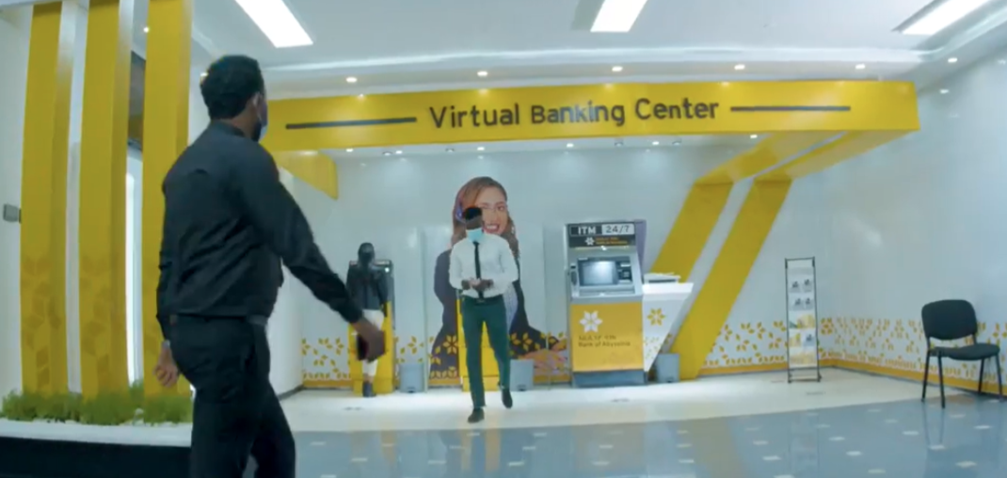

Figure 28. Bank of Abyssinia (BOA) virtual banking center [107]

ITMs can replace traditional banks entirely or be placed alongside a larger physical location with live staff inside to handle more complicated requests.

**Table 5. Estimated number of ITM machines to be employed by banks**

|  |  |  |  |  |
| --- | --- | --- | --- | --- |
| **S/N** | **Bank Name** | **No of Branches** | **No of ITM** | **Average estimated demand of ITM** |
| 1 | [Nib International Bank](https://en.wikipedia.org/w/index.php?title=Nib_International_Bank&action=edit&redlink=1) | 211 | N/A | 8 |
| 2 | [Abay Bank](https://en.wikipedia.org/w/index.php?title=Abay_Bank&action=edit&redlink=1) | 467 | N/A | 12 |
| 3 | [Addis International Bank](https://en.wikipedia.org/w/index.php?title=Addis_International_Bank&action=edit&redlink=1) | 133 | N/A | 3 |
| 4 | [Awash International Bank](https://en.wikipedia.org/wiki/Awash_International_Bank) | 446 | N/A | 11 |
| 5 | [Bank of Abyssinia](https://en.wikipedia.org/w/index.php?title=Bank_of_Abyssinia&action=edit&redlink=1) | 818 | 5 | 16 |
| 6 | [Berhan International Bank](https://en.wikipedia.org/w/index.php?title=Berhan_International_Bank&action=edit&redlink=1) | 327 | N/A | 5 |
| 7 | [Bunna International Bank](https://en.wikipedia.org/w/index.php?title=Bunna_International_Bank&action=edit&redlink=1) | 463 | N/A | 12 |
| 8 | [Commercial Bank of Ethiopia](https://en.wikipedia.org/wiki/Commercial_Bank_of_Ethiopia) | 1824 | N/A | 24 |
| 9 | [Cooperative Bank of Oromia](https://en.wikipedia.org/wiki/Cooperative_Bank_of_Oromia) | 738 | N/A | 14 |
| 10 | [Dashen Bank](https://en.wikipedia.org/w/index.php?title=Dashen_Bank&action=edit&redlink=1) | 800 | N/A | 16 |
| 11 | [Debub Global Bank](https://en.wikipedia.org/w/index.php?title=Debub_Global_Bank&action=edit&redlink=1) | 158 | N/A | 3 |
| 12 | [Enat Bank](https://en.wikipedia.org/wiki/Enat_Bank) | 167 | N/A | 3 |
| 13 | [Lion International Bank](https://anbesabank.com/) | [278](https://anbesabank.com/branch-locator/) | N/A | 4 |
| 14 | [Oromia International Bank](https://en.wikipedia.org/wiki/Oromia_International_Bank) | 500 | N/A | 12 |
| 15 | [Hibret Bank](https://en.wikipedia.org/w/index.php?title=Hibret_Bank_(Ethiopia)&action=edit&redlink=1) | 470 | N/A | 12 |
| 16 | [Wegagen Bank](https://en.wikipedia.org/wiki/Wegagen_Bank) | 400 | N/A | 10 |
| 17 | [Zemen Bank](https://en.wikipedia.org/w/index.php?title=Zemen_Bank&action=edit&redlink=1) | 96 | N/A | 5 |
| 18 | [Development Bank of Ethiopia](https://en.wikipedia.org/wiki/Development_Bank_of_Ethiopia) | 32 | N/A | - |
| 19 | [ZamZam Bank](https://en.wikipedia.org/w/index.php?title=ZamZam_Bank&action=edit&redlink=1) | 75 | N/A | - |
| 20 | [Hijra Bank](https://en.wikipedia.org/w/index.php?title=Hijra_Bank&action=edit&redlink=1) | 72 | N/A | - |
| 21 | [Siinqee Bank](https://en.wikipedia.org/w/index.php?title=Siinqee_Bank&action=edit&redlink=1) | 406 | N/A | - |
| 22 | [Shabelle Bank](https://en.wikipedia.org/w/index.php?title=Shabelle_Bank&action=edit&redlink=1) | 52 | N/A | - |
| 23 | [Amhara Bank](https://en.wikipedia.org/w/index.php?title=Amhara_Bank&action=edit&redlink=1) | 281 | N/A | 9 |
| 24 | Ahadu Bank | 10 | N/A | 2 |
| 26 | Tsedey Bank | 148 | N/A | 4 |
| 27 | Sidama Bank | 16 | N/A | - |
| 28 | Gadaa Bank SC | 70 | N/A | - |
| **Total** | | | **5** | **185** |
| **Estimated Demand** | | | | **180** |

N/A= Not available

* 1. **Global ATM market demand forecasting data**

ATMs are able to provide a wide range of services and banks tend to utilize this electronic banking device, as all others for competitive advantage [4]. According to the study, an ATM transaction is an average of about 6,400 per month compared to 4,300 for human tellers which increase productivity for the banks [108]. ATM Data in Australia are compiled and published by Australian Payments Network (AusPayNet). As of September 2017, there were 32 275 ATMs which are slightly below the peak of nearly 32 900 estimated in December 2016. This represents over 1,300 ATMs per million inhabitants, which is relatively high by international standards [109]. According to the estimates developed by ATM Industry Association or ATMIA, in 2006 the number of ATMs worldwide was over 1.5 million [110] [111].

According to EthSwitch S.C, the development of Ethiopian banking system has largely been affected by the dominance of cash. It is estimated that out of a total population of 100 million less than 10 percent are getting banking services from the estimated report of EthSwitch S.C, [111]. There are company with unique brand that will be connecting all ATM machines and POS terminals from the currently fragmented card alliances [112].

There are 19 banks that are currently shareholders in EthSwitch S.C including national bank of Ethiopia, development bank of Ethiopia and all other commercial banks. Development Bank is in technical process of connecting to EthSwitch. There are 17 Commercial banks in Ethiopia that which are included in the Table [113]. The World Bank has studied different countries from financial access survey of international monetary fund. Ethiopia’s ATM usage as per 100,000 adults in different fisical years as shown in the figure below [114].

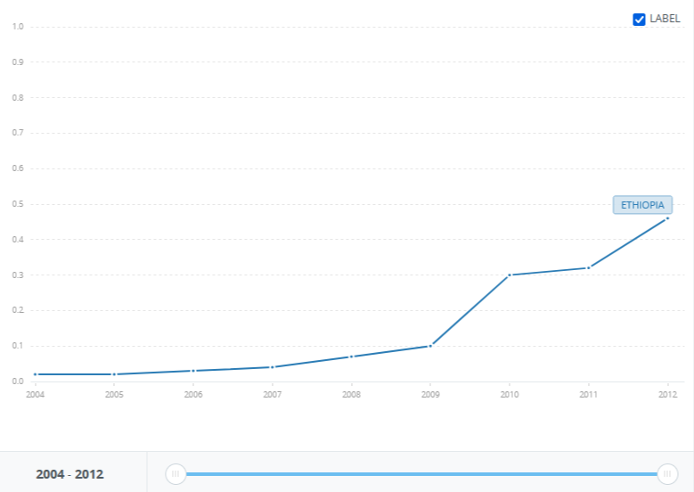

Figure 29. World Bank graph on ATM usage in Ethiopia

* 1. **Ethiopia’s ATM market demand forecasting graphs**

From the actual data of various banks, the demand of ATM and ITM in different budget years is tabulated below; this mainly depends on the financial capability as well as service performance of the bank.

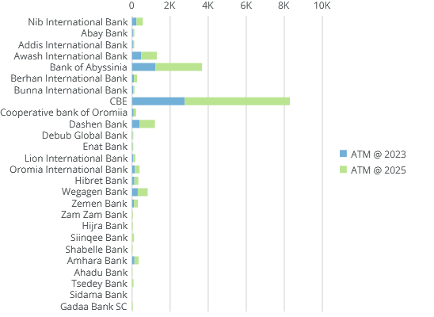

Figure 30. Horizontal bar for ATM demand forecast at 2025

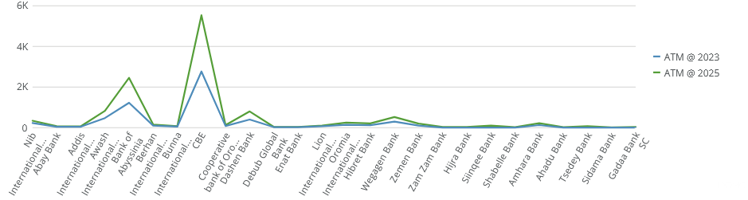

Figure 31. Line chart for ATM demand forecast at 2025

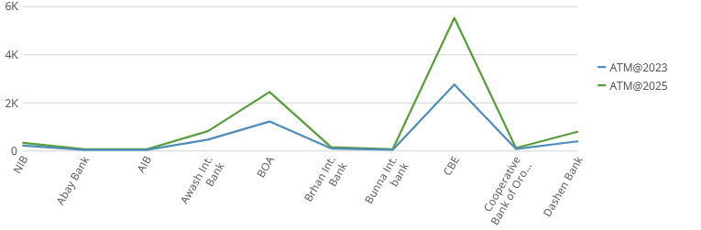

Figure 32. Line chart for ATM demand forecast at 2025 (For the first 10 banks)

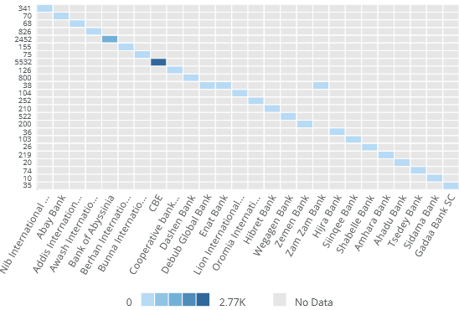

Figure 33. Heat map for ATM demand forecast at 2025

1. **SUMMARY AND CONCLUSION**

The overall demand for domestic assembly either in SKD or CKD category is more economical which promotes the technological transfer here by motivate youngsters to build their capacity in maintenance and troubleshooting of ATM related technologies. There were a few companies who participated in this field but it was not in accordance with the demand and banking development. There are many private companies or individuals who actively helping the banking sector in maintaining and troubleshooting of defected ATMs. Considering all the demands of ATM/ITM machines including the currently operating machines reached more than 6500 in all banks. The expected increment will be above 13000 ATMs in two years period. Total number of operational ATMs will be more than 20000 which have great impact on E-marketing services. These also require developing human manpower to fully utilize the technology to the dead end.

**REFERENCES**

1. *S. Kanwal & N.A. Zafar (2007). Formal model of automatic teller machine system using Z notation, International conference on Emerging technologies (ICET), Islamabad, pp. 131–136.*
2. *Wenninger J & Laster D. (2013). The electronic purse- Current issues in economics and finance, 1(1):1–5. Retrieved from:* [*http://www.newyorkfed.org/*](http://www.newyorkfed.org/) *research/current issues/ci1-1.pdf.*
3. *Ebiringa, O. (2010). Automated teller machine and electronic payment system in automated teller machine and electronic payment system in.* Journal of Sustainable Development in Africa.
4. *Okiro, K., & Ndungu, J. (2013). The impact of mobile and internet banking on performance of financial institutions in Kenya.* European Scientific Journal.
5. *Chandan Kumar (2011). ATM machine, Times Bussiness School.*

*Available at https://www.academia.edu/35481375/ATM_MACHINE*

1. *Fitch TP (2005). Dictionary of banking terms. 5th ed. Hauppauge, NY, USA: Barron’s Educational Series.*
2. *Wenninger J. & Laster D. (1995). The electronic purse. Current Issues in Economics and Finance. 1(1):1–5. Retrieved June 11, 2013, from:* [*http://www.newyorkfed.org/*](http://www.newyorkfed.org/) *research/current issues/ci1-1.pdf.*
3. *What is ITM, MECU Credit Union, 2023? Available at* [*https://www.mecu.com/ITM*](https://www.mecu.com/ITM)*.*
4. *Moses Okechukwu Onyesolu, McChester Odoh, Allwell Ononiwu Akanwa & Victor Chekume Nwasor (2012). Robust Authentication Model for ATM: a Biometric strategy measure for enhancing E-banking security in Nigeria, International Journal of Advanced Research in Computer Science, Volume 3, No. 5.*
5. *James J. & MCAndrews (2003). Automated teller machine network pricing – A review of the literature, Review of network economics, Volume 2, Issue 2.*
6. *ATM or ITM - Which is right for your institution? (PDF), QDS, https://cdn2.hubspot.net/hubfs.*
7. [*Mustafa H. Awwad*](https://www.inderscienceonline.com/doi/abs/10.1504/IJEBANK.2021.117369) *&*[*Hamed M. Shamma*](https://www.inderscienceonline.com/doi/abs/10.1504/IJEBANK.2021.117369) *(2021).Consumer adoption of interactive teller machines: evidence from the Arabian Gulf,* [*International Journal of Electronic Banking*](https://www.inderscienceonline.com/journal/ijebank) [*Vol. 3, No. 1*](https://www.inderscienceonline.com/toc/ijebank/3/1)*.* [*https://doi.org/10.1504/IJEBANK.2021.117369*](https://doi.org/10.1504/IJEBANK.2021.117369)*.*
8. *Mayabrahhmma A. & Vineet K. (2023).Virtual teller machine (VTM) market.*
9. *Available at Interactive Teller Machine (ITM): Pros, Cons, & Future. Available at,* [*https://www.tidalcommerce.com/learn/interactive-teller-machines*](https://www.tidalcommerce.com/learn/interactive-teller-machines)*.*
10. *Bringing personal teller experiences to self-service with ITMs. An NCR banking eBook. Retrieved from ncr.com.*
11. *ATM manufacturers. Available at* [*https://www.imarcgroup.com/*](https://www.imarcgroup.com/rs)*.*
12. [*American Bankers Association*](https://bankingjournal.aba.com/2020/03/despite-slow-pace-of-adoption-banks-are-interested-in-itms/)*. Available at https://www.aba.com/*
13. *3 major differences between automated teller machines ATMs and interactive teller machines (ITMs). Retrieved from wittenbach.com.*
14. *Introduction about ATM. Available at* [*https://www.gstsuvidhakendra.org*](https://www.gstsuvidhakendra.org/introduction-about-atm/)*.*
15. *Retrospective: Impact of COVID-19 on the Expansion of Interactive Teller Machines (ITMs), Aug 08, 2023. ventusgns.com.*
16. *Strong, Rudy, Video Banking ICT Adoption (January 10, 2018).*

*Available at SSRN:* [*https://ssrn.com/abstract=3099802*](https://ssrn.com/abstract=3099802) *or* [*http://dx.doi.org/10.2139/ssrn.3099802*](https://dx.doi.org/10.2139/ssrn.3099802)

1. *ESM Goh Chok Tong (2017). Staying on Top of Our Game. “Speech by Mr Ong Ye Kung, Minister for Education (higher education and skills) and second minister for defense at the launch of the financial services industry transformation map”, MAS PENTHOUSE.*
2. *Kevin Wack & Alan Kline (2017). The Evolution of ATM. Retrieved from www.americanbanker.com.*
3. *Fumiko Hayashi, Richard Sullivan, & Stuart E. Weiner (2003). A guide to the ATM and debit card industry.**Payments system research department, Federal reserve bank of Kansas city, Kansas city, Missouri, USA.*
4. *Available at https://e-payments.blogspot.com/2016/07/history-of-atm-in-netherlands.html*
5. *A guide to the ATM and debit card industry.**Fumiko Hayashi, Richard Sullivan, and Stuart E. Weiner Payments System Research Department, Federal Reserve Bank of Kansas City, Kansas City, Missouri, USA, 2003.*
6. *Bellis, Mary. "History of Automatic Teller Machines or ATM." Thought Co, Sep. 9, 2021, houghtco.com/automatic-teller-machines-atm-1991236.* [*"ATMIA 50th Anniversary Factsheet"*](https://www.atmia.com/files/50th%20Anniversary/50th_ATM_Anniversary_Fact_Sheet_-_06272016.pdf). www.atmia.com. ATM Industry Association. October 2015.
7. *Fumiko Hayashi, Richard Sullivan, and Stuart E. Weiner, 2013. A guide to the ATM and debit card industry.**Payments System Research Department, Federal Reserve Bank of Kansas City, Kansas City, Missouri, USA.*
8. *Janani.V, and L. Hanapraveena, 2014. ATM Transaction Security System Using Biometric Palm Print Recognition. IOSR Journal of Electronics and Communication Engineering (IOSR-JECE). Volume 9, Issue 5, 06 – 11.*
9. *Salem S. M. Khalifa & Kamarudin Saadan, 2013.The formal design model of an automatic teller machine (ATM). Lecture notes on information theory Vol. 1, No. 1.*
10. *Boluwaji A. Akinnuwesi, Faith-Michael E. Uzoka and Adetoba P. Obasa, 2013. Enhancing automated teller machine with multi-lingual and multi-denominational software functionalities. Int. J. Electronic Finance, Vol. 7, No. 2.*
11. *Kinuthia Mungai, 2008.Factors Influencing Effective Use of Automated Teller Machines by Bank Customers in Vol. Thesis, Kenyatta University, Nairobi, Kenya.*
12. *Financial-transaction-card-originated messages — Interchange message specifications, International Standard, ISO 8583, third edition 2023-07.*
13. *Torrorr Bharathan, How ATMs work Automated Teller Machine (ATM). Available at https://www.academia.edu/5787813/How_ATMs_Work_Automated_Teller_Machine_ATM_*
14. *Oracle FLEXCUBE Core Banking Automated Teller Machine User Manual, Release 5.1.0.0.0, Part No. E57304-01, September 2014.*
15. *C. Robat. (2006). ATM Automatic Teller Machine. [Online].*

*Available:* [*http://www.thocp.net/hardware/atm.htm*](http://www.thocp.net/hardware/atm.htm)

1. *J. Bowen. (2010). How ATMs Work. [Online].Available:* [*http://money.howstuffworks.com/atm3.htm*](http://money.howstuffworks.com/atm3.htm)*.*
2. *Available at* [*https://www.howitworksdaily.com/how-do-cash-machines-work/*](https://www.howitworksdaily.com/how-do-cash-machines-work/)
3. *R Hossain, et al... Designing an ATM network based on distributed database systems, no date.*
4. *A. R. Rai (2008). Customer relationship management: Concepts and cases, New Delhi, pp. 97-98.*
5. *Wikipedia the Free Encyclopedia. (2010). Automated Teller Machine. [Online].*
6. *E. W. Croft & B. J. Spencer (2003). Fees and surcharging in automatic teller machine networks: non-bank ATM providers versus large banks.*
7. *ATM Functional Requirements.*

# *Available at https://www.scribd.com/document/503523726/ATM-SYSTEM*

1. *Requirement document for Automatic Teller Machines, August 5.*

[*https://www.cs.toronto.edu/~sme/CSC340F/2005/assignments/inspections/atm.pdf*](https://www.cs.toronto.edu/~sme/CSC340F/2005/assignments/inspections/atm.pdf)

1. *Khalid Al-Saleh & Salaheddine Bendak (2013). An ergonomics evaluation of certain ATM dimensions. International Journal of Occupational Safety and Ergonomics (JOSE), Vol. 19, No. 3, 347–353.*
2. *Australian Bankers’ Association (2001). Industry standard. Automatic teller machines (ATM). Sydney, NSW, Australia: Retrieved June 11, 2013, from:* [*http://www.bankers.asn.au/Industry-*](http://www.bankers.asn.au/Industry-) *Standards/ABAs-Accessibility-of-Electronic- Banking-/ATM Standard.*
3. *Pheasant S. (2003). Body space: anthropometry, ergonomics and the design of work. 2nd ed. London, UK: Taylor & Francis.*
4. *Grandjean E. Fitting the task to the man. A textbook of occupational ergonomics. 4th ed. London, UK: Taylor & Francis; 1988.*
5. *Sanders MS, McCormick EJ. Human factors in engineering and design. 7th ed. New York, NY, USA: McGraw-Hill; 1994.*
6. *Putz-Anderson V, editor (1988). Cumulative trauma disorders. London, UK: Taylor & Francis.*
7. *M. F. Rana, S. Z. Naseem, M. S. Sarfraz and U. Shoaib (2018). Ergonomics Estimation and Dimensions of ATM Usage in Pakistan Indian Journal of Science and Technology, Vol 11(24), DOI: 10.17485/ijst/2018/v11i24/124315.*
8. *Production Line. Available at* [*https://ceopedia.org/index.php/Production_line*](https://ceopedia.org/index.php/Production_line)
9. *Dr. S. Pattnaik & Dr. S. Mishra. Production and operation management, department of mechanical engineering, Lecture.* [*https://www.vssut.ac.in/lecture_notes/lecture1429900757.pdf*](https://www.vssut.ac.in/lecture_notes/lecture1429900757.pdf).
10. *Available at* [*https://www.hongzhousmart.com/competitive-price-all-in-one-money-currency-exchange-atm-kiosk-with-coin-bill-acceptor-4251.html*](https://www.hongzhousmart.com/competitive-price-all-in-one-money-currency-exchange-atm-kiosk-with-coin-bill-acceptor-4251.html)*.*
11. *J. M. Canapi, M. Chan, M. A. Contreras & A. J. Portus (2015). Usability testing of cash-in machines for Filipino use. 6th International Conference on Applied Human Factors and Ergonomics (AHFE 2015) and the Affiliated Conferences, AHFE 2015, Procedia Manufacturing 3, 3486 – 3493.*
12. *Production Systems: Planning, Analysis & Control: By — Riggs, J.L. (4th Edn.) John Wiley & Sons*
13. *Buffa, E.S. & Sarin, K. (8`" Edn.). Modern Production/Operation management, John Wiley & Sons.*
14. *Panneer saivem, R. (2'1 Edn.). Production & Operations Management, PHI.*
15. [*S. Song*](https://sciprofiles.com/profile/author/SU5pVGJDbktjUWtWQnhJQk1iRlNpemtKUDRoMjdOaEt6UU9tMnFZeG0xND0=?utm_source=mdpi.com&utm_medium=website&utm_campaign=avatar_name)*, Y. Tian & D. Zhou (2021). Reverse logistics network design and simulation for automatic teller machines based on carbon emission and economic benefits: A study of the Anhui province ATMs industry.* Sustainability*,* 13*(20), 11373;* [*https://doi.org/10.3390/su132011373*](https://doi.org/10.3390/su132011373)*.*
16. *Use case diagram for bank ATM system. Available at https://www.geeksforgeeks.org/use-case-diagram-for-bank-atm-system/*
17. *MELT-Technologies ATM Training. Available at* [*https://meltechgrp.com/2018-last-quarter-atm training-50-off/*](https://meltechgrp.com/2018-last-quarter-atm%20training-50-off/)
18. *Production volume retrieved from* [*https://www.sisense.com/kpis/manufacturing-kpis/production-volume/*](https://www.sisense.com/kpis/manufacturing-kpis/production-volume/)
19. *What is production volume retrieved from* [*https://fiixsoftware.com/maintenance-metrics/what-is-production-volume/*](https://fiixsoftware.com/maintenance-metrics/what-is-production-volume/)
20. *E. Matys, N. Meller, I. Nekrasova, & E. Rechapova (2019). Determination of the optimal production volume of the industrial enterprise. E3S Web of Conferences, 91, 08069. https://doi.org/10.1051/e3sconf /20199108091.*
21. *Seven Common KPIs for Production Monitoring Using - Visual Management to Drive Productivity.Whitepaper.www.redlion.net.*
22. *KPI Basics retrieved from https://www.kpi.org/kpi-basics/kpi-development/*
23. *L. Zhu, C. Johnsson, J. Mejvik, M. Varisco & M. Schiraldi (2017). Key performance indicators for manufacturing operations management in the process industry. Proceedings of the 2017 IEEE IEEM.*
24. *Top 15 smart factory KPIs available at* [*https://iot-analytics.com/wp/wp-content/uploads/2022/08/Top-15-Smart-factory-KPIs-Manufacturing-KPI-vf-min.png*](https://iot-analytics.com/wp/wp-content/uploads/2022/08/Top-15-Smart-factory-KPIs-Manufacturing-KPI-vf-min.png)
25. *Gerdes, Geoffrey R. & Jack K. Walton (2002). The use of checks and other noncash payment instruments in the United States, Board of governors of the Federal Reserve System. Federal Reserve Bulletin, pp. 360-374.*
26. *National Digital Payments Strategy 2021–2024.*
27. *World statistics available at* [*https://www.statista.com/statistics/1350455/number-of-atm-in-south-africa-by-bank/*](https://www.statista.com/statistics/1350455/number-of-atm-in-south-africa-by-bank/)
28. *Number of ATMs worldwide 2009-2022(2023).* [*Statista Research Department*](https://www.statista.com/aboutus/our-research-commitment)*.Available at https://www.statista.com/statistics/741708/number-of-atms-worldwide/*
29. *Prof. Jyotiranjan Hota (2013). Growth of ATM industry in India. Article, CSI Communications. www.csi-india.org.*
30. *Edelweiss (2012). Indian payment industry in 2012. Available at http:// tsi.swishdesign.com.au/wp-content/ uploads/2011/08/Indian-Payment- Industry-2012.pdf fetched on 11.09.2012.*
31. *Global leader in ATM and banking asset management-Tellerex available at https://www.tellerex.com/news*
32. *3 major difference between ATM and ITM retrieved from* [*https://wittenbach.com/*](https://wittenbach.com/3-major-differences-between-automated-teller-machines-atms-and-interactive-teller-machines-itms/)
33. *Financial management operating expense retrieved from* [*https://www.netsuite.com/portal/resource/articles/*](https://www.netsuite.com/portal/resource/articles/financial-management/operating-expense.shtml)
34. *Garrison, Ray H. (2006). “Managerial Accounting”. Jakarta: Salemba Four. Hanggana, Sri. Basic Principles of Cost Accounting. Surakarta: Mediatama.*
35. *Mulyadi (2007). Cost Accounting, 5th Edition, 7th Print. YKPN Publishing and Printing Unit, Yogyakarta.*
36. *Process costing retrieved from* [*https://www.netsuite.com/portal/resource/articles/accounting/*](https://www.netsuite.com/portal/resource/articles/accounting/process-costing.shtml)
37. *R. L. Putri (2017). Analysis of production cost calculations using process costing method in SULI TOFU factory.CORE.core.ac.uk.*
38. *Ainul Hossain Tushar, APRM, CSSBB, LFPC, SFPC. Introduction to Manufacturing and Non-manufacturing costs. Available at https://www.linkedin.com/pulse/introduction-manufacturing-non-manufacturing-costs*
39. *Total manufacturing costs available at https://www.industery.com/blog*
40. [*A. B. Ganorkar*](https://www.researchgate.net/scientific-contributions/Ashwin-B-Ganorkar-2140582812?_sg%5B0%5D=huiWkWqXKquiMLzBVqnTcj4e2_fKdfEguMiSiDQ91DH_eu6Ha2uVOamDGNwePIvCQR_e8mc.UtfjYSNTiU4w2sBDjCOZS0Z2Zv8rlnLbRuUvyd-P3BXFWk_G8g5ifTHcH6vNCaWCdzmJggneSNs-OAhMuEBbRg&_sg%5B1%5D=d70PRKksF52kFHUqYHdeqdojrVTMzx0mAV0ZMDjGOqZDgFodwOov27yIi08FAf3RhQKFL1E.KsJsr4hfH9YmK7cYiVB5bGYpkTtSPCXCInTpOO43sLT_ULtzbR0m6iZg_UHzsbCFx4mn2xtqMIuqtq8TobrcgA&_tp=eyJjb250ZXh0Ijp7ImZpcnN0UGFnZSI6Il9kaXJlY3QiLCJwYWdlIjoiX2RpcmVjdCIsInBvc2l0aW9uIjoicGFnZUhlYWRlciJ9fQ)*,* [*R. R. Lakhe*](https://www.researchgate.net/scientific-contributions/RR-Lakhe-2034690675?_sg%5B0%5D=huiWkWqXKquiMLzBVqnTcj4e2_fKdfEguMiSiDQ91DH_eu6Ha2uVOamDGNwePIvCQR_e8mc.UtfjYSNTiU4w2sBDjCOZS0Z2Zv8rlnLbRuUvyd-P3BXFWk_G8g5ifTHcH6vNCaWCdzmJggneSNs-OAhMuEBbRg&_sg%5B1%5D=d70PRKksF52kFHUqYHdeqdojrVTMzx0mAV0ZMDjGOqZDgFodwOov27yIi08FAf3RhQKFL1E.KsJsr4hfH9YmK7cYiVB5bGYpkTtSPCXCInTpOO43sLT_ULtzbR0m6iZg_UHzsbCFx4mn2xtqMIuqtq8TobrcgA&_tp=eyJjb250ZXh0Ijp7ImZpcnN0UGFnZSI6Il9kaXJlY3QiLCJwYWdlIjoiX2RpcmVjdCIsInBvc2l0aW9uIjoicGFnZUhlYWRlciJ9fQ) *&* [*K. N. Agrawal*](https://www.researchgate.net/scientific-contributions/Kamalkishor-N-Agrawal-2141681970?_sg%5B0%5D=huiWkWqXKquiMLzBVqnTcj4e2_fKdfEguMiSiDQ91DH_eu6Ha2uVOamDGNwePIvCQR_e8mc.UtfjYSNTiU4w2sBDjCOZS0Z2Zv8rlnLbRuUvyd-P3BXFWk_G8g5ifTHcH6vNCaWCdzmJggneSNs-OAhMuEBbRg&_sg%5B1%5D=d70PRKksF52kFHUqYHdeqdojrVTMzx0mAV0ZMDjGOqZDgFodwOov27yIi08FAf3RhQKFL1E.KsJsr4hfH9YmK7cYiVB5bGYpkTtSPCXCInTpOO43sLT_ULtzbR0m6iZg_UHzsbCFx4mn2xtqMIuqtq8TobrcgA&_tp=eyJjb250ZXh0Ijp7ImZpcnN0UGFnZSI6Il9kaXJlY3QiLCJwYWdlIjoiX2RpcmVjdCIsInBvc2l0aW9uIjoicGFnZUhlYWRlciJ9fQ) *(2019). Cost and productivity analysis of the manufacturing industry using TDABC & MOST. South African Journal of Industrial Engineering, Vol 30(1), pp 196-208.*
41. *ATM Industry Trends, White Paper, External Document © 2019 Infosys Limited*
42. Adapted from UNIDO (2000). Structure of Production Costs in Footwear Manufacture.
43. *Available at* [*https://igzy.com/challenges-and-solutions-to-manage-bank-and-atm-security*](https://igzy.com/challenges-and-solutions-to-manage-bank-and-atm-security/)
44. *Robin Arnfield (2017). Guide to ATM total cost of ownership guide, Global insights and best practices for ATM ownership and manage. ATM Marketplace.*
45. *ATM machine cost retrieved from https://costhack.com/*
46. *Available at https://blog.qualitydatasystems.com/atm-cost*
47. *Available at https://www.tellerex.com/post/new-atm-cost?*
48. *Nasreen Iqbal, Automation Teller Machine (XYZ-ATM), Project Management, Software Testing, De Montfort University.*
49. *M. S. Kotiso (2019). Financial Sector Development and Economic Growth in Ethiopia: Literature Review, Research Journal of Finance and Accounting, Vol.10, No.5, ISSN 2222-1697 (Paper) ISSN 2222-2847 (Online). DOI: 10.7176/RJFA*
50. *A. Gashayie & Dr M.Singh (2016). Development of Financial Sector in Ethiopia: Literature Review, Journal of Economics and Sustainable Development ISSN 2222-1700 (Paper). ISSN 2222-2855 (Online) Vol.7, No.7,. www.iiste.org.*
51. *National Bank of Ethiopia. (NBE) (20013/14) Annual Report.*
52. *IMF (2014). Financial access survey WP/05/166.*
53. *Gobezie, Getaneh (2002). Evaluating the potential of microfinance as Anti-poverty strategy: A case of the Amhara Credit and savings Institution-in Gebrehiwot Ageba (ed.).*
54. *Center for Financial Inclusion. Available at https://www.centerforfinancialinclusion.org/.*
55. *The role of the ATM in driving financial inclusion worldwide- Extending financial services to the unbanked, An NCR whitepaper, 2017. Available at ncr.com*
56. *PYMNTS Global Cash Index. Available at* [*https://www.pymnts.com/study/global-cash-study/*](https://www.pymnts.com/study/global-cash-study/)*.*
57. *Available at* [*https://addisbiz.com/business-news/4212-best-banks-in-ethiopia-for-2022-2021-budget-year/*](https://addisbiz.com/business-news/4212-best-banks-in-ethiopia-for-2022-2021-budget-year/)
58. *Hana Settearagachew (2017). Assessing the Automated Teller Machine (ATM) service quality of Commercial Bank of Ethiopia (CBE) in Addis Ababa. St. Mary’s University School of Graduate Studies, Thesis.*
59. *Khan, M.A. (2010). An empirical study of ATM service quality and customer satisfaction in  
     Pakistani banks. European journal of social sciences. Vol 13 (3). pp. 333-343.*
60. *Olabanji O. M, Mpofu Ka (2014). Comparison of weighted decision matrix, and analytical hierarchy process for CAD design of reconfigurable assembly fixture, Conference on assembly technologies and systems, Industrial engineering department, Tshwane university of technology, Pretoria, South Africa, CIRP.*
61. *Interactive Teller Machine (ITM): Pros, Cons, & Future.*

*Available at,* [*https://www.tidalcommerce.com/learn/interactive-teller-machines*](https://www.tidalcommerce.com/learn/interactive-teller-machines)

1. *Banks of Abyssinia. Available at* [*https://banksethiopia.com/banks/*](https://banksethiopia.com/banks/bank-of-abyssinia/)
2. *Virtual banking in Ethiopia. Available at* [*https://www.bankofabyssinia.com/*](https://www.bankofabyssinia.com/virtual-banking-in-ethiopia/)
3. *Abor, J. (2014). Technological Innovations and Banking in Ghana: An evaluation of customers’ perceptions.* Accra, University of Ghana, Legon*.*
4. *S. Mitchell & C. Thompson (2017). Recent developments in the ATM industry, Reserve bank of*

*Australia-Quarterly Bulletin.*

1. *R. Simutis, D. Dilijonas, L. Bastina & J. Friman (2007). A flexible neural network for ATM cash demand forecasting, 6th WSEAS Int. conference on computational intelligence, Man-machine systems and cybernetics, Tenerife, Spain.*
2. *EthSwitch S.C. (2017). Ethiopay Statistical Bulletin.* EthioPay statistical data.
3. *National Bank of Ethiopia (2009).* Instruction to handle the national card switch project. *Addis Ababa: National Bank of Ethiopia.*
4. *Getachew Tadesse (2018). Challenges and opportunities of Ethiopay ATM service, Dissertation, Addis Ababa University College of Business and Economics.*
5. [*World bank Indicators:*](https://data.worldbank.org/indicator/)[*FB.ATM.TOTL.P5*](https://data.worldbank.org/indicator/FB.ATM.TOTL.P5)